Slot d OS LAB WORK
EXP 1:
AIM:
CREATE A NEW PROCESS BY INVOKING THE APPROPRIATE SYSTEM CALL AND ITS RESPECTIVE PROCESSS USING SYSTEM CALL.
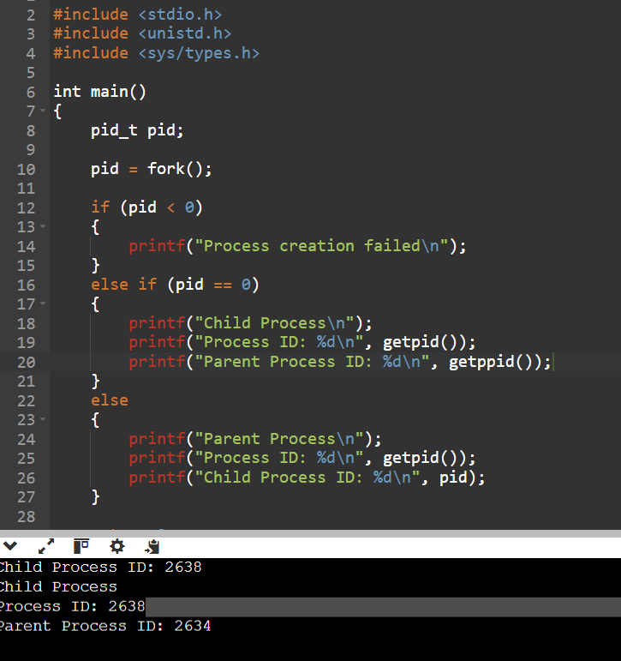

Exp no 2 :
AIM:
IDENTIFY THE SYSTEM CALL TO COPY THE CONTENT OF ONE FILE TO ANOTHER AND ILLUSTRATE THE SAME USING C PROGRAM.
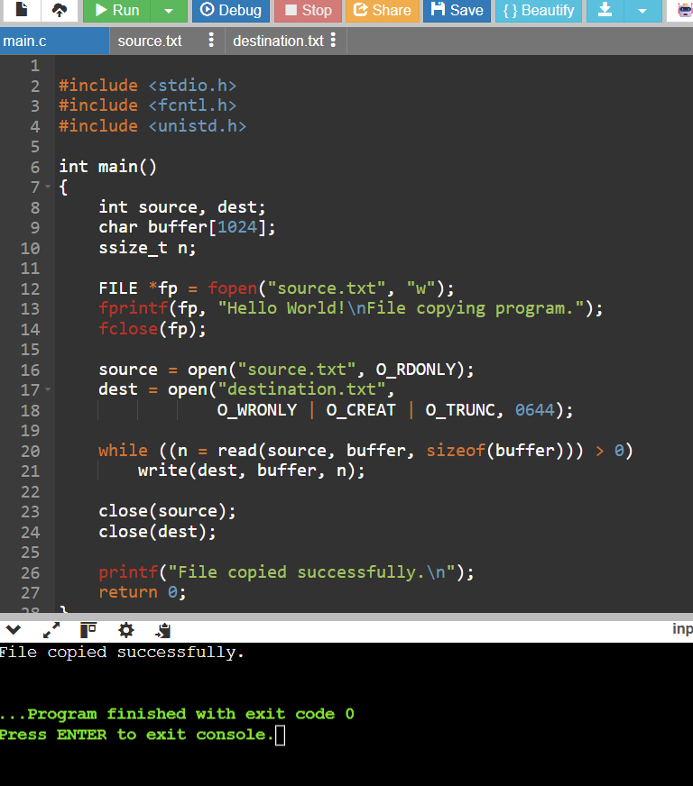

Exp 3 :
AIM:
TO IMPLEMENT A C PROGRAM TO SOLVE THE PRODUCER CONSUMER SYNCHRONIZATION PROBLEM USING POSIX SEMAPHORES AND MUTEX LOCKS ENSURING COORDINATED PROCESS EXECUTION

SOURCE CODE :
#include <stdio.h>
#include <pthread.h>
#include <semaphore.h>
#include <unistd.h>
#define SIZE 5
int buffer[SIZE];
int in = 0, out = 0;
sem_t empty, full;
pthread_mutex_t mutex;
void *producer(void *arg)
{
int item;
for (item = 1; item <= 5; item++)
{
sem_wait(&empty);
pthread_mutex_lock(&mutex);
buffer[in] = item;
printf("Producer produced: %d\n", item);
in = (in + 1) % SIZE;
pthread_mutex_unlock(&mutex);
sem_post(&full);
sleep(1);
}
return NULL;
}
void *consumer(void *arg)
{
int item, i;
for (i = 1; i <= 5; i++)
{
sem_wait(&full);
pthread_mutex_lock(&mutex);
item = buffer[out];
printf("Consumer consumed: %d\n", item);
out = (out + 1) % SIZE;
pthread_mutex_unlock(&mutex);
sem_post(&empty);
sleep(1);
}
return NULL;
}
int main()
{
pthread_t p, c;
sem_init(&empty, 0, SIZE);
sem_init(&full, 0, 0);
pthread_mutex_init(&mutex, NULL);
pthread_create(&p, NULL, producer, NULL);
pthread_create(&c, NULL, consumer, NULL);
pthread_join(p, NULL);
pthread_join(c, NULL);
sem_destroy(&empty);
sem_destroy(&full);
pthread_mutex_destroy(&mutex);
return 0;
}

OUTPUT:
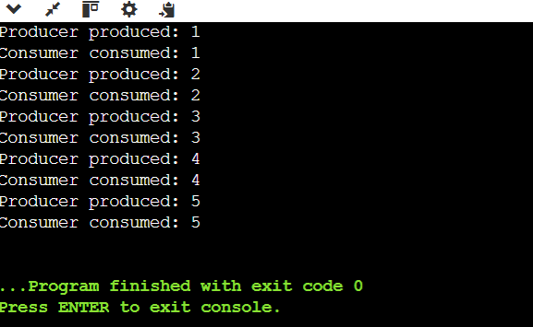

Exp-4
AIM: IMPLEMENTATION OF SOCKET COMMUNICATION USING TCP/OPP AND CLIENT SERVER USING ARCHITECTURE
Server code:
#include <stdio.h>
#include <winsock2.h>
#pragma comment(lib, "ws2_32.lib")
int main()
{
WSADATA wsa;
SOCKET server_socket, client_socket;
struct sockaddr_in server, client;
int client_len;
char buffer[1024] = {0};
WSAStartup(MAKEWORD(2, 2), &wsa);
server_socket = socket(AF_INET, SOCK_STREAM, 0);
server.sin_family = AF_INET;
server.sin_addr.s_addr = INADDR_ANY;
server.sin_port = htons(8080);
bind(server_socket, (struct sockaddr *)&server,
sizeof(server));
listen(server_socket, 3);
printf("Server waiting for client...\n");
client_len = sizeof(client);
client_socket = accept(server_socket,
(struct sockaddr *)&client,
&client_len);
int n = recv(client_socket, buffer,
sizeof(buffer) - 1, 0);
if (n > 0)
{
buffer[n] = '\0';
printf("Client says: %s\n", buffer);
send(client_socket, "Hello from server!",
(int)sizeof("Hello from server!") - 1, 0);
}
closesocket(client_socket);
closesocket(server_socket);
WSACleanup();
return 0;
}
Client code :
#include <stdio.h>
#include <winsock2.h>
#include <ws2tcpip.h>

int main()
{
WSADATA wsa;
SOCKET client_socket;
struct sockaddr_in server;
char buffer[1024] = {0};
WSAStartup(MAKEWORD(2, 2), &wsa);
client_socket = socket(AF_INET, SOCK_STREAM, 0);
server.sin_family = AF_INET;
server.sin_port = htons(8080);
server.sin_addr.s_addr = inet_addr("127.0.0.1");
if (connect(client_socket,
(struct sockaddr *)&server,
sizeof(server)) == SOCKET_ERROR)
{
printf("Connection failed. Start the server first.\n");
closesocket(client_socket);
WSACleanup();
return 1;
}
send(client_socket, "Hello from client!",
(int)sizeof("Hello from client!") - 1, 0);
int n = recv(client_socket, buffer,
sizeof(buffer) - 1, 0);
if (n > 0)
{
buffer[n] = '\0';
printf("Server says: %s\n", buffer);
}
closesocket(client_socket);
WSACleanup();
return 0;
}
Output:
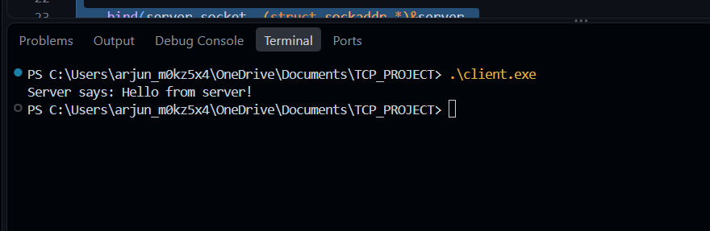

Exp 5 :
AIM: TO IMPLEMENT A JAVA PROGRAM TO PERFORM AND SIMULATE MULTITHREADING
class MyThread extends Thread {
public void run() {
for (int i = 1; i <= 5; i++) {
System.out.println(
Thread.currentThread().getName()
+ " - Count: " + i
);
}
}
}

public class Main {
public static void main(String[] args) {
MyThread t1 = new MyThread();
MyThread t2 = new MyThread();
t1.setName("Thread 1");
t2.setName("Thread 2");
t1.start();
t2.start();
}
}
Output:

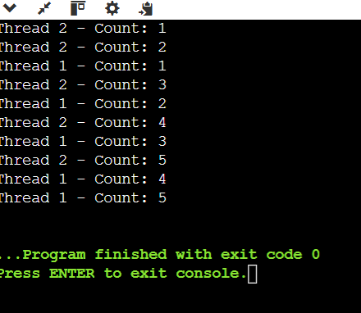

EXP 6 :
AIM:
CONSTRUCT A C PROGRAM TO IMPLEMENT PRE EMPTIVE PRIORITY SCHEDULING ALGORITHM.
#include <stdio.h>
int main()
{
int n, i, time = 0, completed = 0;
int at[20], bt[20], rt[20], pr[20];
int ct[20], tat[20], wt[20];
int highest, min_priority;
float avg_tat = 0, avg_wt = 0;
printf("Enter number of processes: ");
scanf("%d", &n);
for (i = 0; i < n; i++)
{
printf("Enter arrival time, burst time and priority for P%d: ",
i + 1);
scanf("%d %d %d", &at[i], &bt[i], &pr[i]);
rt[i] = bt[i];
}
while (completed < n)
{
highest = -1;
min_priority = 9999;
for (i = 0; i < n; i++)
{
if (at[i] <= time && rt[i] > 0 &&
pr[i] < min_priority)
{
min_priority = pr[i];
highest = i;
}
}
if (highest == -1)
{
time++;
continue;
}
rt[highest]--;
time++;
if (rt[highest] == 0)
{
completed++;
ct[highest] = time;
tat[highest] = ct[highest] - at[highest];
wt[highest] = tat[highest] - bt[highest];
avg_tat += tat[highest];
avg_wt += wt[highest];
}
}
printf("\nPID\tAT\tBT\tPR\tCT\tTAT\tWT\n");
for (i = 0; i < n; i++)
{
printf("P%d\t%d\t%d\t%d\t%d\t%d\t%d\n",
i + 1, at[i], bt[i], pr[i],
ct[i], tat[i], wt[i]);
}
printf("\nAverage Turnaround Time = %.2f",
avg_tat / n);
printf("\nAverage Waiting Time = %.2f\n",
avg_wt / n);
return 0;
}
OUTPUT:
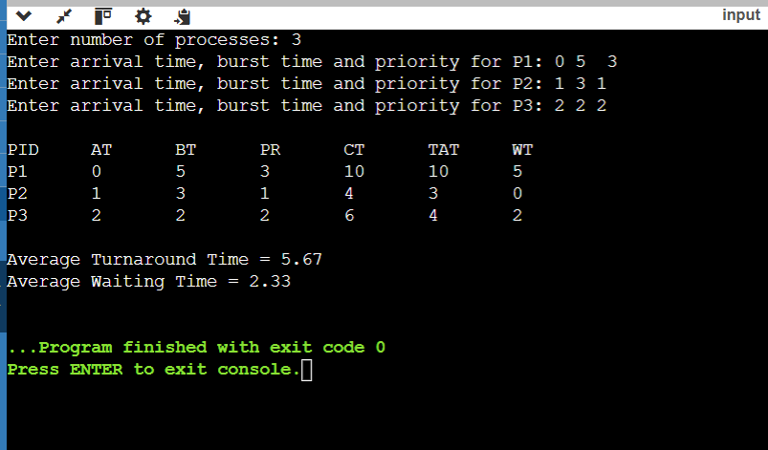

EXP 7 :
CONSTRUCT A C PROGRAM TO IMPLEMENT A NON PREEMPTIVE SJF ALGORITHM
#include <stdio.h>
int main()
{
int n, i, time = 0, completed = 0;
int at[20], bt[20], ct[20], tat[20], wt[20];
int done[20] = {0}, p;
float avg_tat = 0, avg_wt = 0;
printf("Enter number of processes: ");
scanf("%d", &n);
for (i = 0; i < n; i++)
{
printf("Enter arrival time and burst time for P%d: ", i + 1);
scanf("%d %d", &at[i], &bt[i]);
}
while (completed < n)
{
p = -1;
for (i = 0; i < n; i++)
{
if (at[i] <= time && done[i] == 0)
{
if (p == -1 || bt[i] < bt[p])
p = i;
}
}
if (p == -1)
{
time++;
continue;
}
time += bt[p];
ct[p] = time;
tat[p] = ct[p] - at[p];
wt[p] = tat[p] - bt[p];
done[p] = 1;
completed++;
avg_tat += tat[p];
avg_wt += wt[p];
}
printf("\nPID\tAT\tBT\tCT\tTAT\tWT\n");
for (i = 0; i < n; i++)
{
printf("P%d\t%d\t%d\t%d\t%d\t%d\n",
i + 1, at[i], bt[i], ct[i], tat[i], wt[i]);
}
printf("\nAverage Turnaround Time = %.2f", avg_tat / n);
printf("\nAverage Waiting Time = %.2f\n", avg_wt / n);
return 0;
}
OUTPUT:
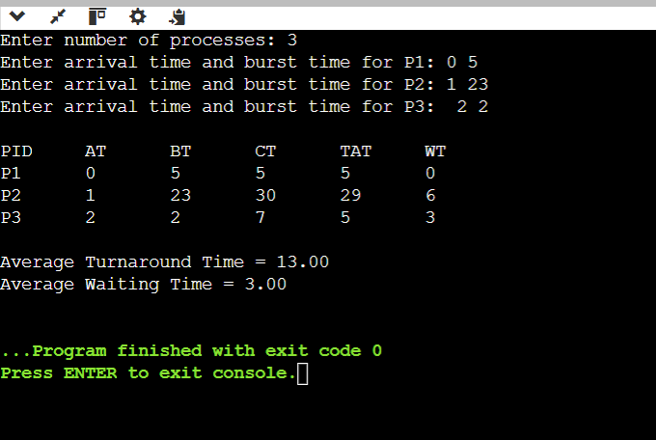

EXP NO 8 :
CONSTRUCT A C PROGRAM TO SIMULATE ROUND ROBIN SCHEDULING ALGORITHM
#include <stdio.h>
int main()
{
int n, tq, i, time = 0, completed = 0;
int at[20], bt[20], rt[20], ct[20], tat[20], wt[20];
float avg_tat = 0, avg_wt = 0;
printf("Enter number of processes: ");
scanf("%d", &n);
for (i = 0; i < n; i++)
{
printf("Enter arrival time and burst time for P%d: ", i + 1);
scanf("%d %d", &at[i], &bt[i]);
rt[i] = bt[i];
}
printf("Enter time quantum: ");
scanf("%d", &tq);
while (completed < n)
{
int executed = 0;
for (i = 0; i < n; i++)
{
if (at[i] <= time && rt[i] > 0)
{
executed = 1;
if (rt[i] > tq)
{
time += tq;
rt[i] -= tq;
}
else
{
time += rt[i];
rt[i] = 0;
ct[i] = time;
completed++;
}
}
}
if (executed == 0)
time++;
}
printf("\nPID\tAT\tBT\tCT\tTAT\tWT\n");
for (i = 0; i < n; i++)
{
tat[i] = ct[i] - at[i];
wt[i] = tat[i] - bt[i];
avg_tat += tat[i];
avg_wt += wt[i];
printf("P%d\t%d\t%d\t%d\t%d\t%d\n",
i + 1, at[i], bt[i], ct[i], tat[i], wt[i]);
}
printf("\nAverage Turnaround Time = %.2f", avg_tat / n);
printf("\nAverage Waiting Time = %.2f\n", avg_wt / n);
return 0;
}
OUTPUT:
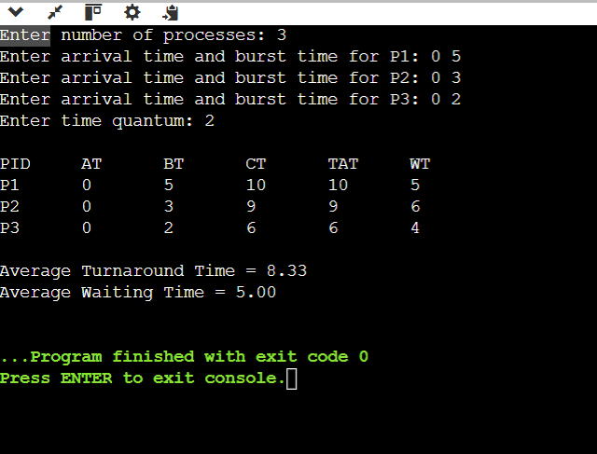

EXP 9:
CONSTRUCT A C PROGRAM TO IMPLENT FIRST COME FIRST SERVE ALGORITHM
#include <stdio.h>
int main()
{
int n, i, time = 0;
int at[20], bt[20], ct[20], tat[20], wt[20];
float avg_tat = 0, avg_wt = 0;
printf("Enter number of processes: ");
scanf("%d", &n);
for (i = 0; i < n; i++)
{
printf("Enter arrival time and burst time for P%d: ", i + 1);
scanf("%d %d", &at[i], &bt[i]);
}
for (i = 0; i < n; i++)
{
if (time < at[i])
time = at[i];
time += bt[i];
ct[i] = time;
tat[i] = ct[i] - at[i];
wt[i] = tat[i] - bt[i];
avg_tat += tat[i];
avg_wt += wt[i];
}
printf("\nPID\tAT\tBT\tCT\tTAT\tWT\n");
for (i = 0; i < n; i++)
{
printf("P%d\t%d\t%d\t%d\t%d\t%d\n",
i + 1, at[i], bt[i], ct[i], tat[i], wt[i]);
}
printf("\nAverage Turnaround Time = %.2f", avg_tat / n);
printf("\nAverage Waiting Time = %.2f\n", avg_wt / n);
return 0;
}

OUTPUT:
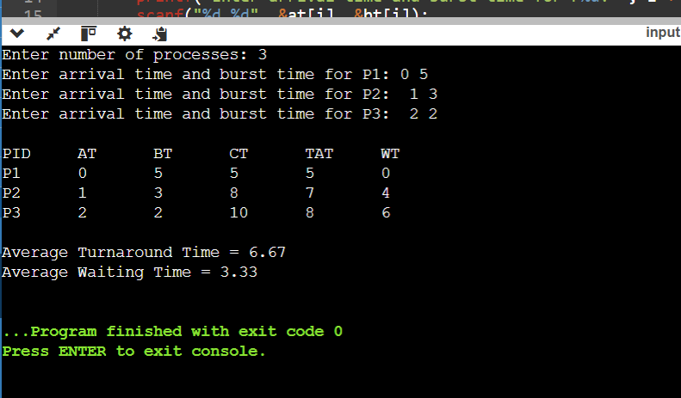

EX NO 10 :
AIM: IMPLEMENT PROCESS SYNCHRONIZATION USING C PROGRAM.
SOURCE CODE:
#include <stdio.h>
#include <stdbool.h>
bool flag[2] = {false, false};
int turn;
int main()
{
int process;
for (process = 0; process < 2; process++)
{
int other = 1 - process;
flag[process] = true;
turn = other;
while (flag[other] && turn == other)
{
/* Wait */
}
printf("Process %d is in Critical Section\n", process);
printf("Process %d is executing\n", process);
flag[process] = false;
printf("Process %d has exited Critical Section\n", process);
}
return 0;
}

OUTPUT:
